Thickness

Definition
# Source: AI Source: Provided by: [Data Path: Persons Table -> ID Column: 1, Name_En Column: Motasem Essam] -> From: [ChatGPT] on [7/20/2026]
In geometry, thickness is the smallest dimension of a solid object or material measured between two opposite surfaces.
In simple terms:
Thickness describes how thick or thin an object is.
$$\boxed{\text{Thickness}=\text{Distance Between Opposite Surfaces}}$$
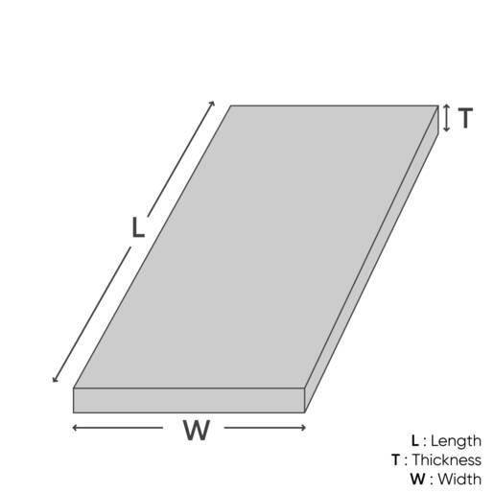
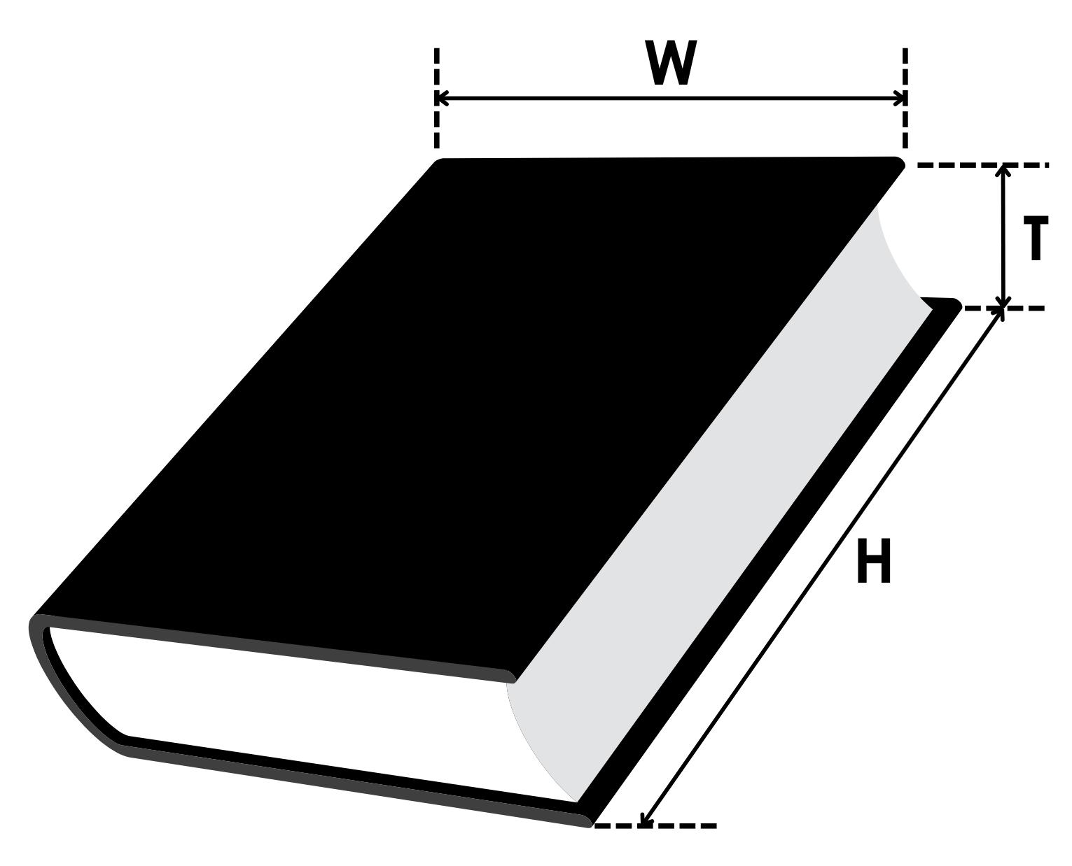
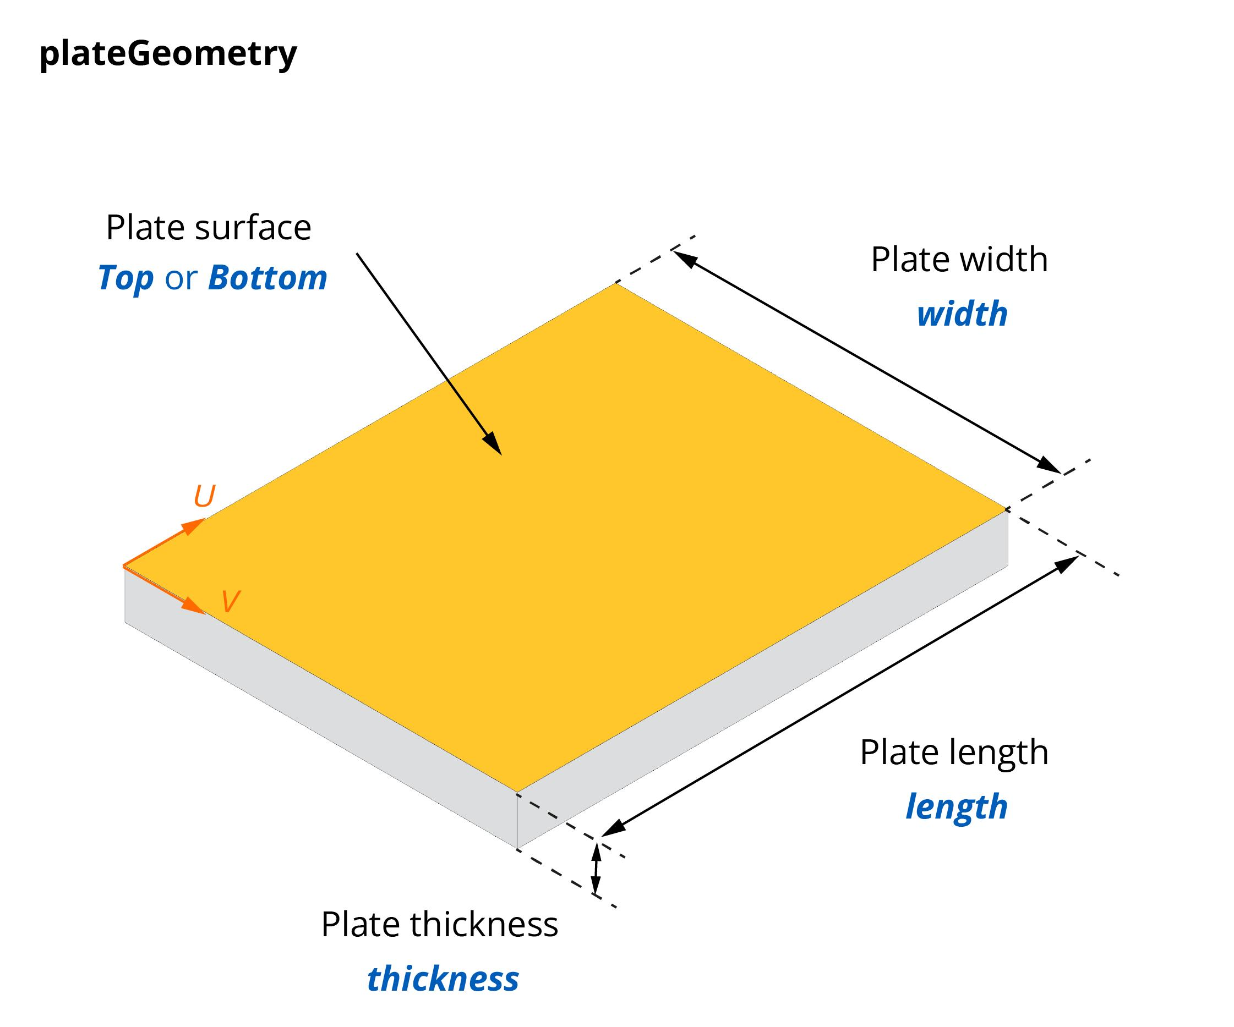
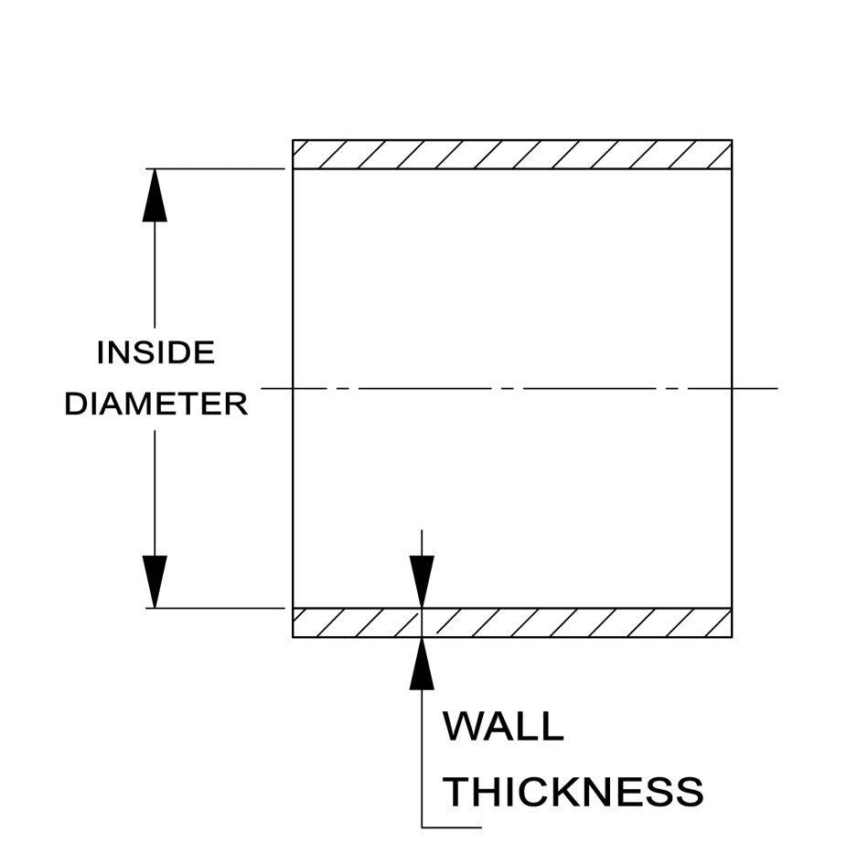
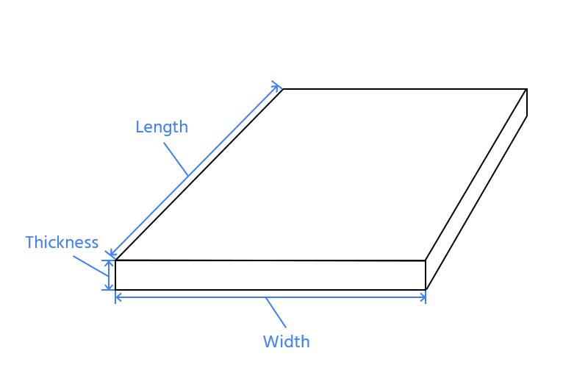
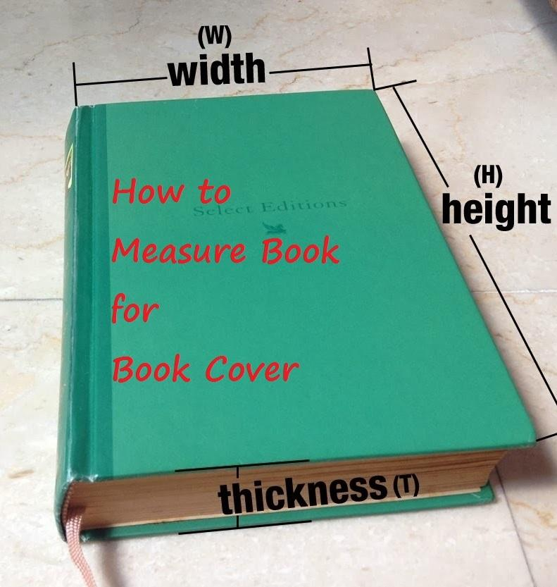

Characteristics
# Source: AI Source: Provided by: [Data Path: Persons Table -> ID Column: 1, Name_En Column: Motasem Essam] -> From: [ChatGPT] on [7/20/2026]
Thickness:
- Is a linear measurement.
- Measures the distance between two opposite surfaces.
- Is often represented by:
$$t$$
or sometimes
$$d$$
depending on context.
- Is usually the smallest dimension of an object.
- Is measured in linear units.
- Is commonly used for plates, sheets, walls, books, panels, coatings, pipes, and layers.
$$\boxed{t≥0}$$

Thickness in Geometry
# Source: AI Source: Provided by: [Data Path: Persons Table -> ID Column: 1, Name_En Column: Motasem Essam] -> From: [ChatGPT] on [7/20/2026]
Unlike length, width, and height, thickness is generally used when one dimension is much smaller than the others.
Example: Sheet
A sheet may have:
$$\text{Length}=100\text{ cm} \\ \text{Width}=50\text{ cm} \\ \text{Thickness}=0.2\text{ cm}$$
The smallest dimension is called the thickness.

Example: Book
# Source: AI Source: Provided by: [Data Path: Persons Table -> ID Column: 1, Name_En Column: Motasem Essam] -> From: [ChatGPT] on [7/20/2026]
A book may have:
- Height
- Width
- Thickness
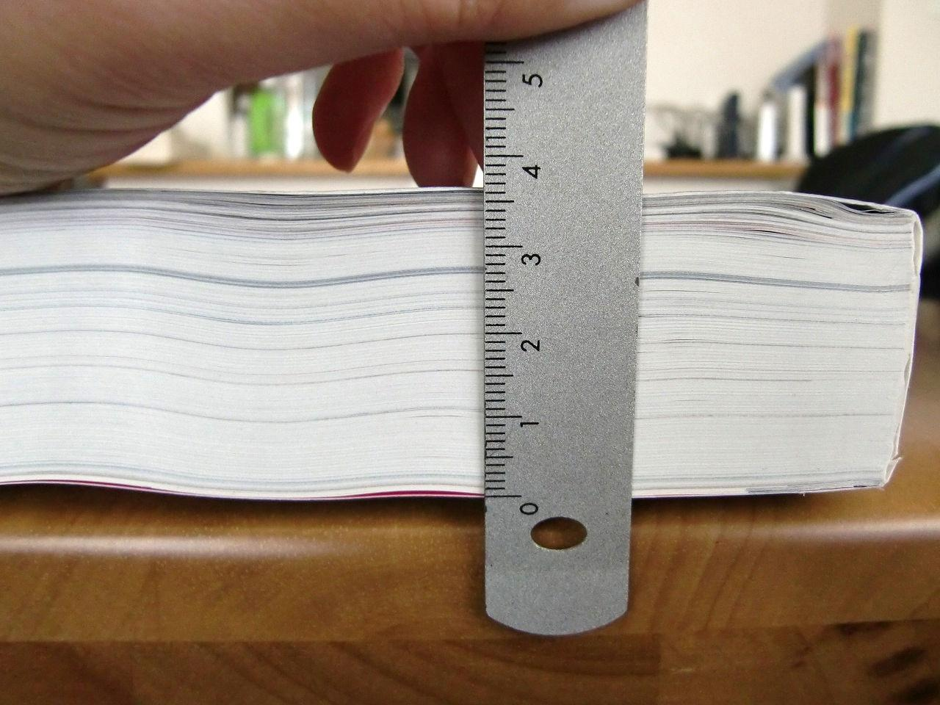


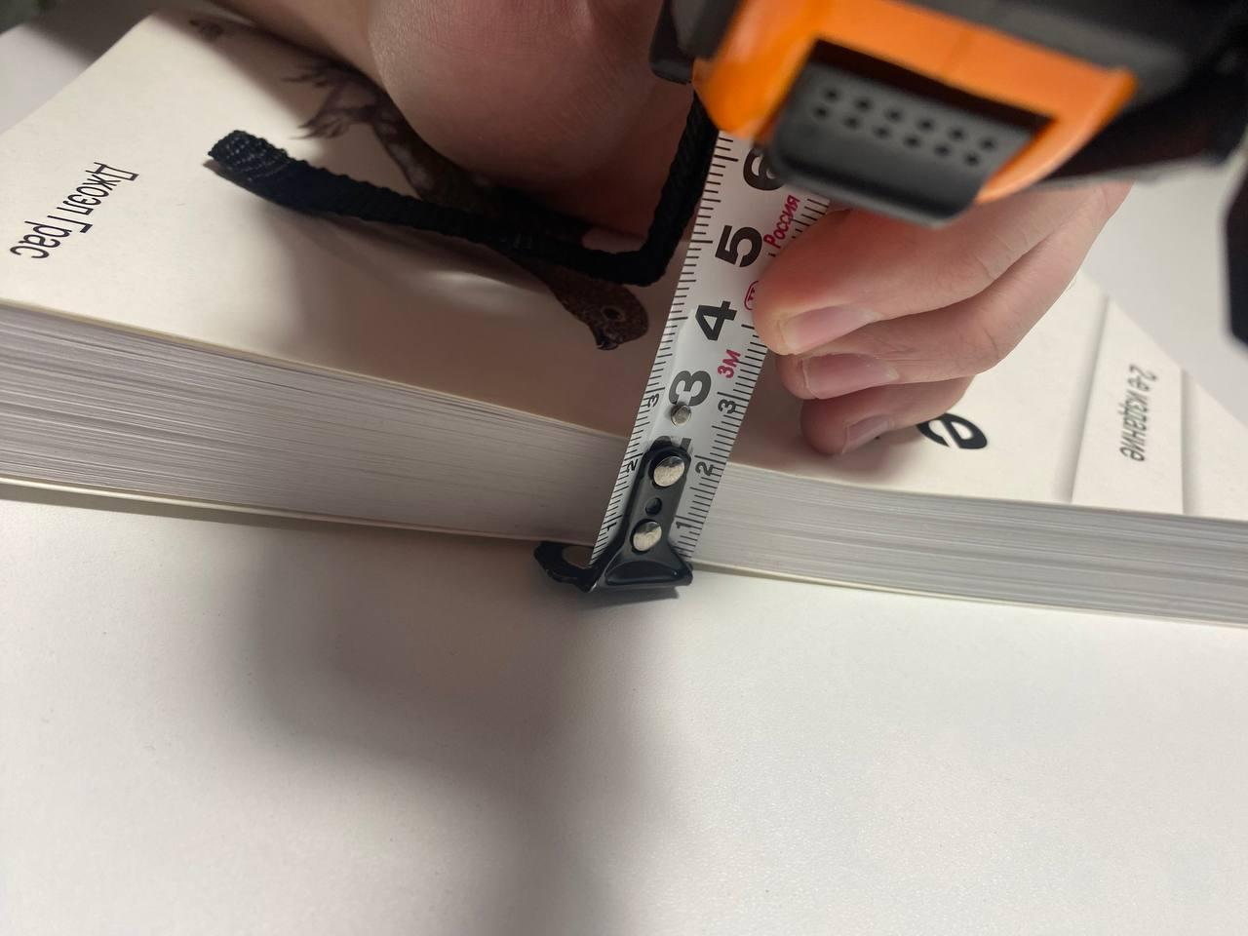
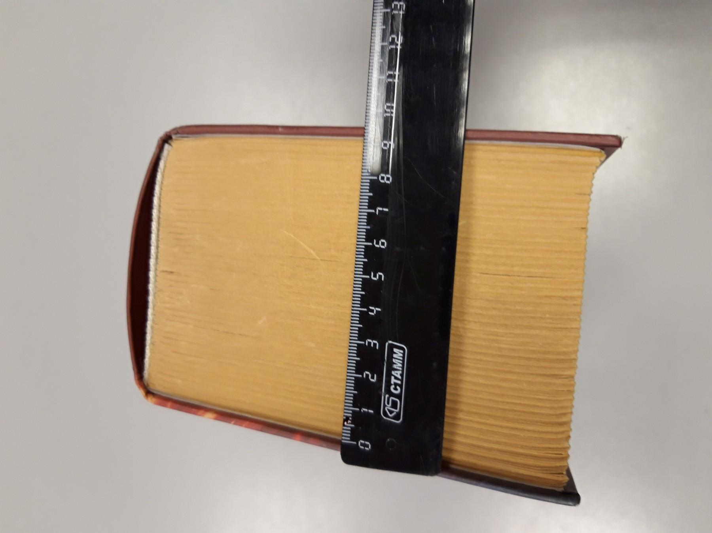


The thickness measures the distance between the front cover and back cover.

Example: Wall
# Source: AI Source: Provided by: [Data Path: Persons Table -> ID Column: 1, Name_En Column: Motasem Essam] -> From: [ChatGPT] on [7/20/2026]
For a wall:
$$\boxed{\text{Thickness}=\text{Distance Between the Two Faces}}$$
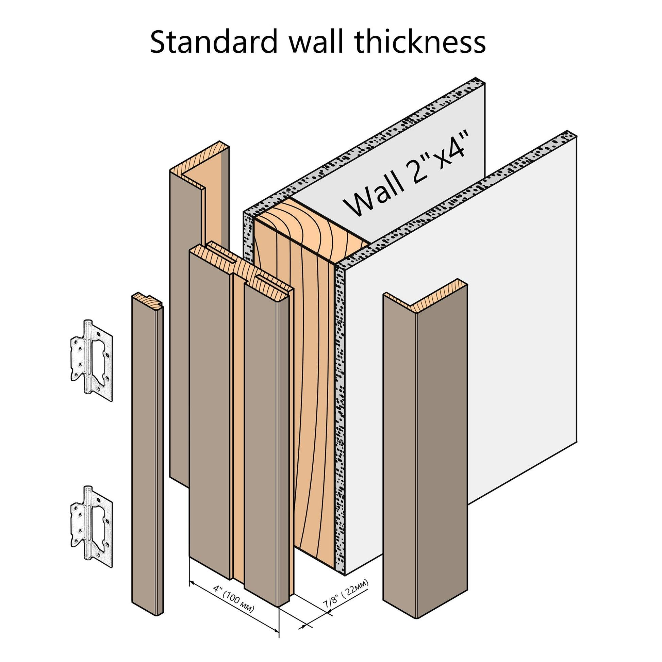
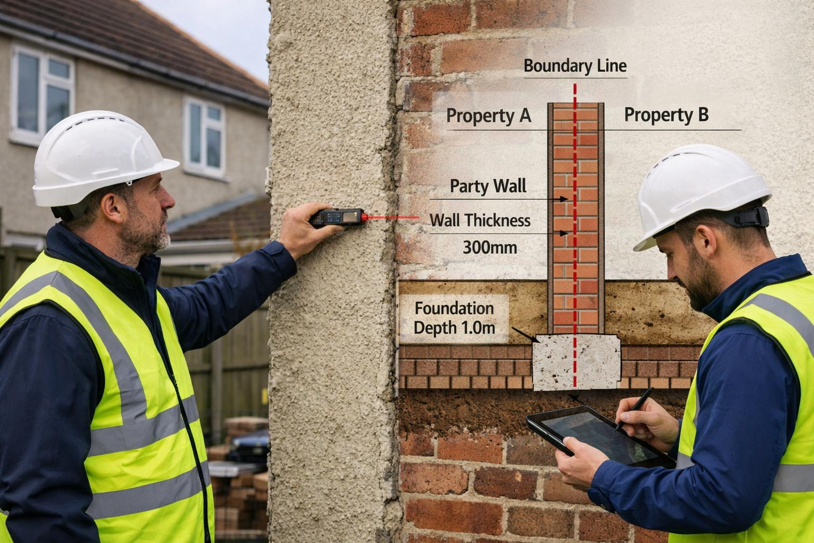
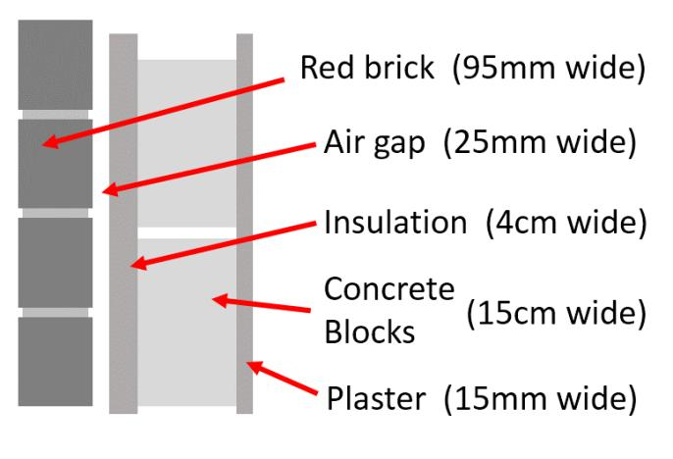
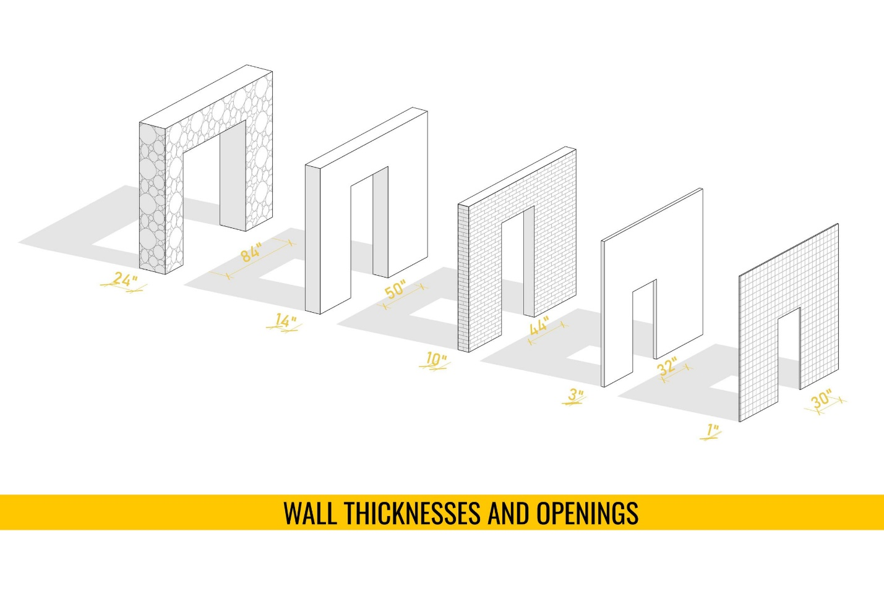


Thickness vs. Height
# Source: AI Source: Provided by: [Data Path: Persons Table -> ID Column: 1, Name_En Column: Motasem Essam] -> From: [ChatGPT] on [7/20/2026]
These concepts are different.
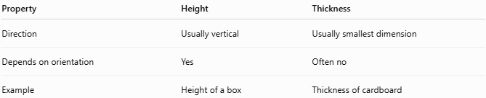
Property | Height | Thickness
Direction | Usually vertical | Usually smallest dimension
Depends on orientation | Yes | Often no
Example | Height of a box | Thickness of cardboard
A thin box may have:
$$h=20\text{ cm}$$
and
$$t=0.3\text{ cm}$$

Thickness vs. Width
# Source: AI Source: Provided by: [Data Path: Persons Table -> ID Column: 1, Name_En Column: Motasem Essam] -> From: [ChatGPT] on [7/20/2026]
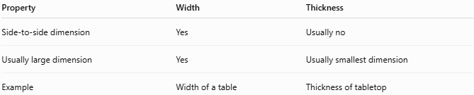
Property | Width | Thickness
Side-to-side dimension | Yes | Usually no
Usually large dimension | Yes | Usually smallest dimension
Example | Width of a table | Thickness of tabletop

Thickness vs. Depth
# Source: AI Source: Provided by: [Data Path: Persons Table -> ID Column: 1, Name_En Column: Motasem Essam] -> From: [ChatGPT] on [7/20/2026]
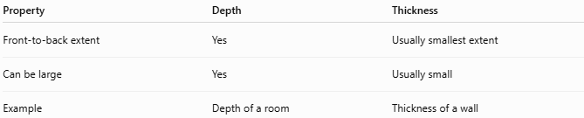
Property | Depth | Thickness
Front-to-back extent | Yes | Usually smallest extent
Can be large | Yes | Usually small
Example | Depth of a room | Thickness of a wall

Thickness in Solids
# Source: AI Source: Provided by: [Data Path: Persons Table -> ID Column: 1, Name_En Column: Motasem Essam] -> From: [ChatGPT] on [7/20/2026]
For a rectangular prism:
$$V=lwh$$
If one dimension is much smaller than the others, that dimension is often called thickness.
Example:
$$l=100 \\ w=50 \\ t=1$$
then:
$$V=lwt$$

Thickness in Layers
# Source: AI Source: Provided by: [Data Path: Persons Table -> ID Column: 1, Name_En Column: Motasem Essam] -> From: [ChatGPT] on [7/20/2026]
Thickness is often used to describe layers.
Examples:
- Paint layer
- Metal sheet
- Glass pane
- Coating
- Ice layer
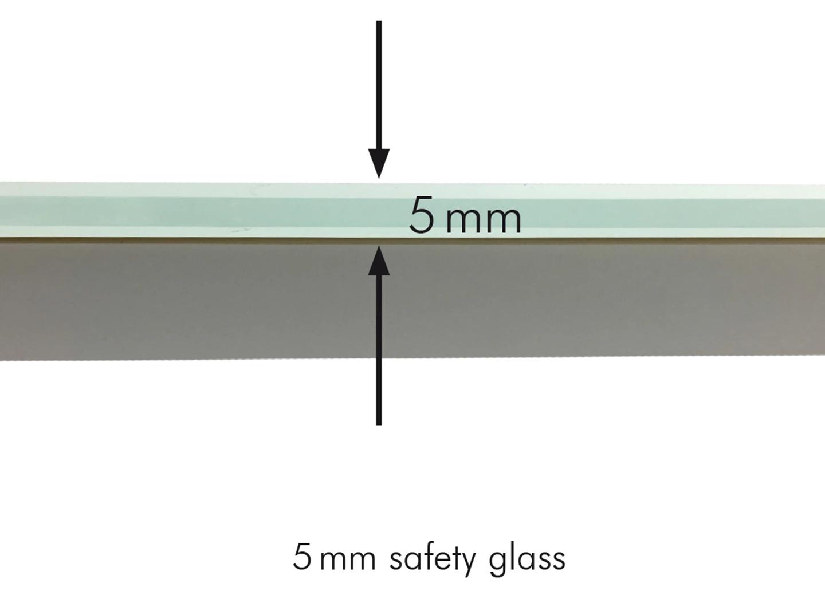

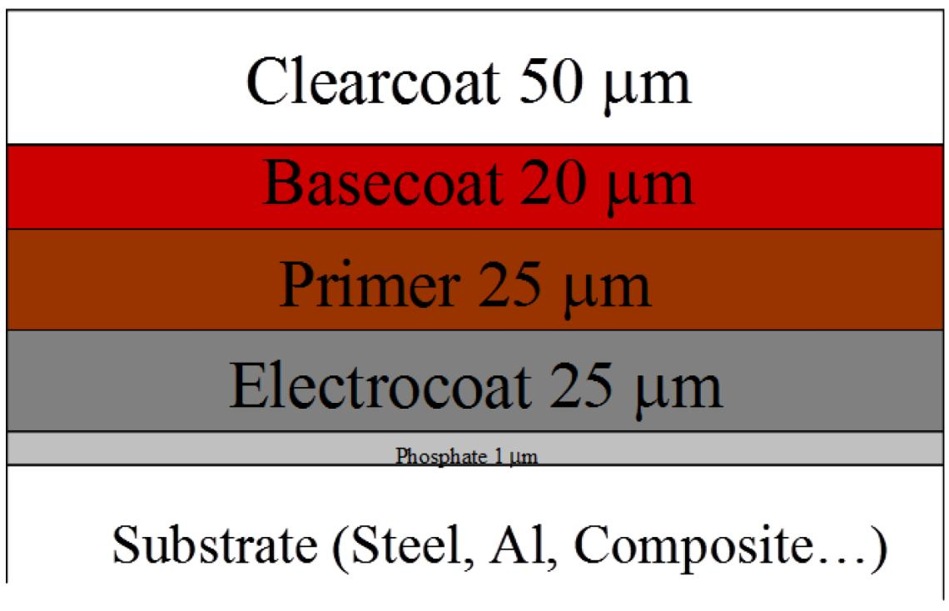
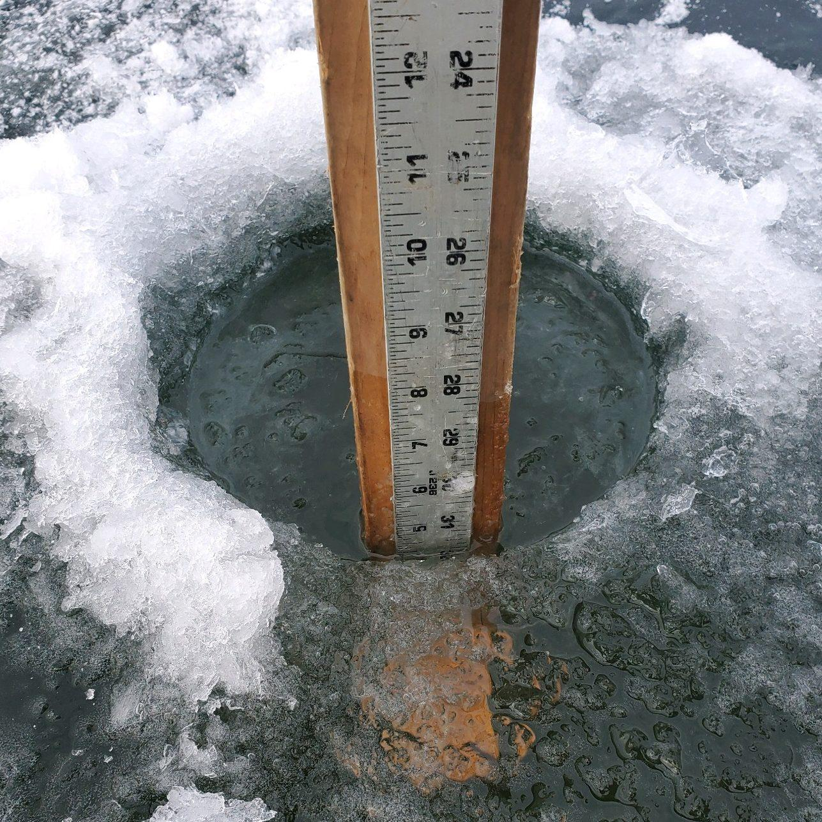

Mathematical Interpretation
# Source: AI Source: Provided by: [Data Path: Persons Table -> ID Column: 1, Name_En Column: Motasem Essam] -> From: [ChatGPT] on [7/20/2026]
Thickness is a one-dimensional quantity.
$$\boxed{\left[t\right]=L}$$
where $L$ is the dimension of length.
Common units:
- mm
- cm
- m
- in
- ft
Examples:
$$t=2\text{ mm} \\ t=0.5\text{ cm} \\ t=3\text{ m}$$

Thickness in Cross Sections
# Source: AI Source: Provided by: [Data Path: Persons Table -> ID Column: 1, Name_En Column: Motasem Essam] -> From: [ChatGPT] on [7/20/2026]
For many geometric objects, thickness can be viewed as the distance through a cross section.
Example:
A pipe wall has thickness:
$$\boxed{t=r_{o}-r_{i}}$$
where:
- $r_{o}$ = outer radius
- $r_{i}$ = inner radius
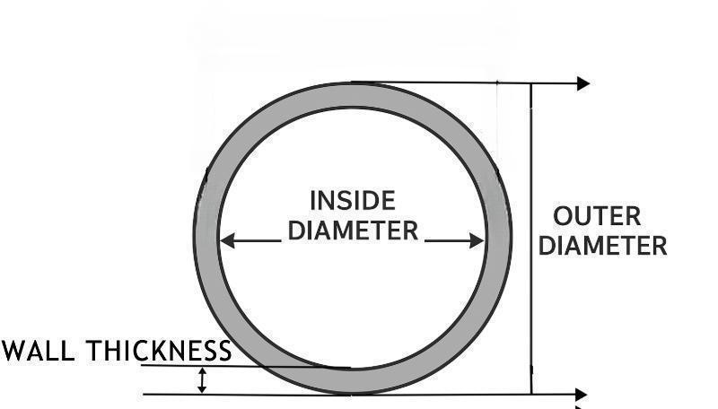
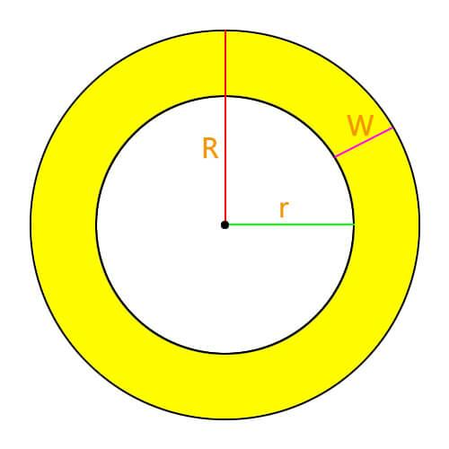
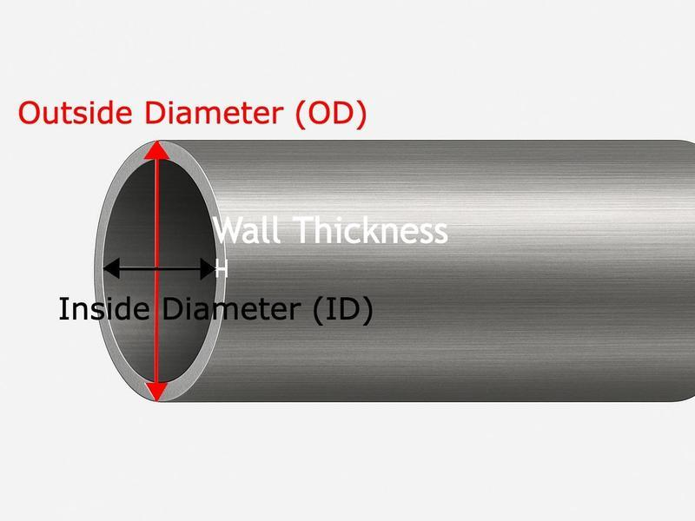
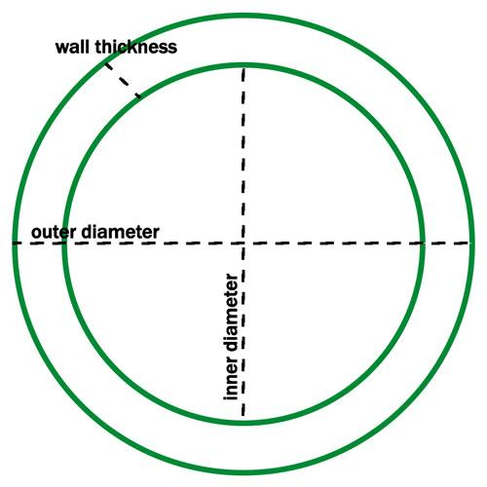
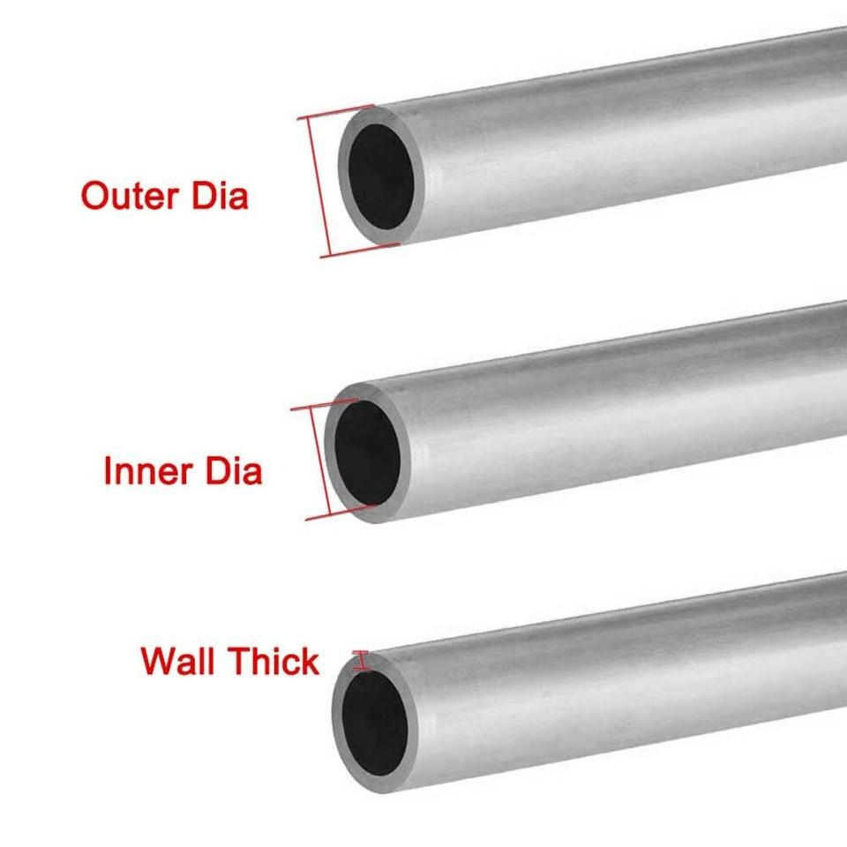

Applications
# Source: AI Source: Provided by: [Data Path: Persons Table -> ID Column: 1, Name_En Column: Motasem Essam] -> From: [ChatGPT] on [7/20/2026]
Thickness is important in:
- Geometry
- Measurement Theory
- Engineering
- Architecture
- Technical Drawing
- Mechanical Design
- Construction
- Manufacturing
- Materials Science
- CAD (Computer-Aided Design)
- 3D Modeling
- Structural Design
- Product Design

Advantages
# Source: AI Source: Provided by: [Data Path: Persons Table -> ID Column: 1, Name_En Column: Motasem Essam] -> From: [ChatGPT] on [7/20/2026]
Understanding thickness helps to:
- Describe the thickness of sheets, plates, walls, and layers.
- Define the smallest dimension of thin objects.
- Calculate volume and surface area.
- Determine material requirements.
- Support structural and mechanical design.
- Specify manufacturing and construction dimensions.
- Analyze layers, coatings, and material sections.
- Support accurate technical drawings and 3D models.

Limitations
# Source: AI Source: Provided by: [Data Path: Persons Table -> ID Column: 1, Name_En Column: Motasem Essam] -> From: [ChatGPT] on [7/20/2026]
Thickness:
- Is a one-dimensional measurement.
- Usually represents a relatively small dimension.
- May depend on the measurement location for irregular objects.
- Often requires clearly defined opposite surfaces.
- Does not by itself describe the complete size of an object.
- May vary across non-uniform materials or surfaces.
- Does not describe area or volume by itself.

Key Points
# Source: AI Source: Provided by: [Data Path: Persons Table -> ID Column: 1, Name_En Column: Motasem Essam] -> From: [ChatGPT] on [7/20/2026]
$$\boxed{\text{Thickness}=\text{Smallest Linear Dimension}}$$
Thickness:
- Is a linear measurement.
- Measures distance between opposite surfaces.
- Usually represents the smallest dimension.
- Is used for sheets, walls, books, coatings, layers, and thin solids.
- Is measured in linear units.
- Is distinct from length, width, height, and depth.

Conclusion
# Source: AI Source: Provided by: [Data Path: Persons Table -> ID Column: 1, Name_En Column: Motasem Essam] -> From: [ChatGPT] on [7/20/2026]
Thickness is the linear distance between two opposite surfaces of an object and is typically used to describe the smallest dimension of a material, layer, or solid. It is especially important for sheets, plates, walls, books, coatings, pipes, and layered structures, where the thickness is significantly smaller than the object's length, width, height, or depth. In geometry and measurement theory, thickness is classified as a linear measurement and is expressed using standard units of length.

